Practical 3

Top of Form

**Given the file structure shown below, answer the following:**

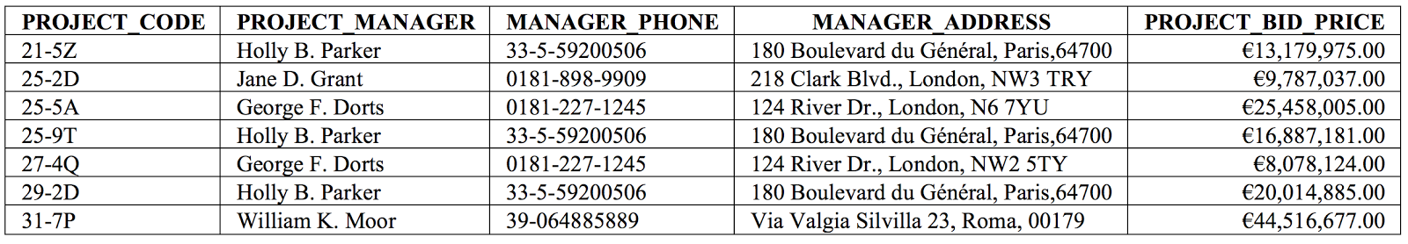

**1. How many records does the file contain, and how many fields are there per record?**

7 records

5 fields per record

**2. What problem would you encounter if you wanted to produce a listing by city? How would you solve this problem by altering the file structure?**

You wouldn't be able to as the address fields consist of the entire address not each part of the address. You would have to create seperate columns for each part of the address, e.g. one for house number, one for street name, one for city and one for postal code etc. This would open up more search options.

**3. If you wanted to produce a listing of the file contents by last name, area code, city, county, or postcode, how would you alter the file structure?**

Same as above, you would have to break each column up in to more columns so that you can search by these criteria, other whys you are limited to what you can search.

**4. What data redundancies do you detect, and how could these redundancies lead to anomalies?**

Holly B, Parker is repeated 3 times and George F. Dorts is repeated 2 times. Although they have different project codes each time, the data could be reformatted to allow the data to be combined together. By doing this it can save space and reduce redundancies in the data.

**Given the file structure shown below, answer the following:**

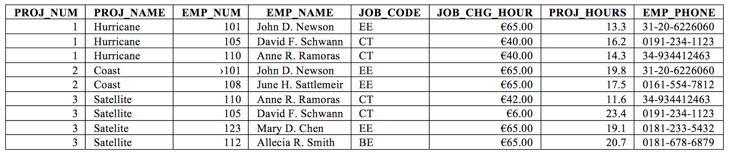

**a. How many records does the file contain, and how many fields are there per record?**

9 records

8 fields per record

**b. Identify and discuss the serious data redundancy problems exhibited by the file structure shown above.**

There seems to be quite a lot of redundant data throughout the table. The first thing that springs to mind is the use of a PROJ_NUM and PROJ_NAME. There's no need for both columns, one or the other is fine. EMP_NAME also has a lot of repeated data in it, namely repetitions of people which could have their data combined into one record to reduce redundancy. The same can be said for EMP_PHONE. It would probably be a good idea to reduce all this data down in to smaller tables which would allow for better organisation.

**c. Looking at the EMP_NAME and EMP_PHONE contents, what change(s) would you recommend?**

Break the EMP_NAME up into separate fields, first name and sir name. As well as getting rid of the separators in the numbers of EMP_PHONE.

**d. Identify the different data sources in the above file structure?**

PROJ, EMP, JOB etc

Bottom of Form